CAPSTONE PROJECT-1

**EDA ON HOTEL BOOKING ANALYSIS**



*STATEMENT:*

* For this project we will be analyzing Hotel Booking data. This data set contains booking information for a city hotel and a resort hotel, and includes information such as when the booking was made, is canceled or not canceled, market segment, country, the number of adults, children and babies and the number of available parking spaces.
* Hotel industry is a very volatile industry and the bookings depends on above factors and many more.
* The main objective behind this project is to explore and analyze data to discover important factors that govern the bookings and give insights to hotel management, which can confirm various campaigns to boost the business and performance.

*WORK FLOW:*

* So we divide our work flow into following 3 steps-

**Data Cleaning**

**and**

**Manipulation**

**Exploratory**

**Data Analysis (EDA)**

**Data Collection and**

**understanding**

EDA will be divided into following 3 analysis-

1. **Univariate Analysis:** Univariate analysis is the simplest of the three analyses where the data you are analyzing is only one variable.
2. **Bivariate Analysis:** Bivariate analysis is where you are comparing two variables to study their relationships.
3. **Multivariate Analysis:** Multivariate analysis is similar to Bivariate analysis but you are comparing more than two variables.

At

*Data Collection and Understanding:*

After collecting data its very important to understand our data, so we have our hotel booking analysis data which have 119390 rows and 46 columns. Lets understand these 46 columns.

**Hotel:** Resort or City Hotel.

**Is_Canceled:** Value indicating if the booking was Canceled (1) or Not Canceled (0).

**Lead_time:** Number of days that elapsed between the entering date of the booking and the arrival date.

**Arrival_Date_Year:** Year of arrival date.

**Arrival_Date_Month:** Month of arrival date.

**Arrival_Date_Week_Number:** Week number of year for arrival date.

**Arrival_Date_Day_of_Month:** Date of arrival date.

**Stays_in_weekend_nights:** Number of weekend nights.

**Stays_in_week_nights:** Number of week nights.

**Country:** Country of origin.

**Booking Id:** Id’s of the bookings made.

**Market_Segment:** Market segment designation. (TA/TO)

Distribution_Channel: Booking distribution channel. (TA/TO)

**Is_repeated_guest:** is a repeated guest (1) or not (0).

**Previous_Cancelation:** Number of previous bookings that were cancelled by the customer prior to the current booking.

**Previous_bookings_not_canceled:** Number of previous bookings not canceled by the customer prior to the current booking.

**Deposit_type:** No deposit, non-refund, refundable.

Agent: Number or id of the travel agency that made the booking.

Company: Number or id of the company that made the booking.

**Days_in_waiting_list:** Number of days the booking was in the waiting list before it was confirmed to the customer.

**Customer_type:** type of customer (contract, group, transient, transient party)

**Adults:** Number of adults.

**Children:** Number of children.

**Babies:** Number of babies.

**Meal:** Type of mean booked. (BB, HB)

**ADR:** Average daily rate as defined by dividing the sum of all lodging transactions by the total number of staying nights.

**Required_car_parking_spaces:** Number of car parking spaces required by customer.

**Total_of_special_requests:** Number of special requests made by customer.

**Reservation_status:** Reservation last status.

**Reservation_status_date:** Status date.

**Reserved_room_type:** Code of room type reserved.

**Assigned_room_type:** code for the type of room assigned to the booking.

**Booking_changes:** Number of changes made to the booking from the moment the booking was entered until the moment of check-in or cancelation.

**Exploratory Data Analysis (EDA)**

While doing hotel-wise analysis of given hotel booking dataset, we answered following questions:

1. Understanding the distribution of arrival dates, including the most common arrival days and summary statistics for lead times.
2. Identify peak booking months and analyze reasons for spikes in bookings, including holidays or events.
3. Calculate summary statistics for ADR and explore differences between Resort Hotel and City Hotel bookings.
4. Analyze the distribution of required car parking spaces for each hotel type and determine if one type attracts more guests with cars.
5. Compare the total number of special requests made by different customer types (e.g., Transient, Group) and identify which customer type makes more requests.
6. Understand the distribution of meal plans (e.g., BB, HB, FB, SC) and identify any patterns or preferences.
7. Investigate the distribution of required car parking spaces and special requests by hotel type and meal plan.
8. Compare the distribution of meal plans among different customer types (e.g., Transient, Group) to identify preferences.
9. Understand the distribution of bookings across different market segments and calculate summary statistics for lead times within each segment.
10. Analyze the distribution of bookings through different booking channels (e.g., online travel agents, direct bookings) and calculate the percentage of bookings through each channel.
11. Calculate the proportion of repeated guests and investigate their booking behavior. Identify any patterns or differences in preferences compared to first time guests.
12. Explore the impact of a guest's booking history on their likelihood of canceling a current booking. Calculate cancellation rates based on previous cancellations and non canceled bookings.
13. Understand the distribution of reserved and assigned room types. Calculate summary statistics for the consistency between reserved and assigned room types.
14. Analyze the impact of booking changes on cancellation rates. Calculate cancellation rates for bookings with different numbers of changes.
15. Explore how room type preferences vary across different customer types (e.g., Transient, Group). Identify if certain customer types have specific room preferences.
16. To understand the distribution of arrival dates and calculate summary statistics for lead times in MySQL, we are using SQL queries.

**Most common arrival days**:

To find the most common arrival days, we can use the group by clause along with the count() function.

This query will show the most common arrival dates along with their respective counts.

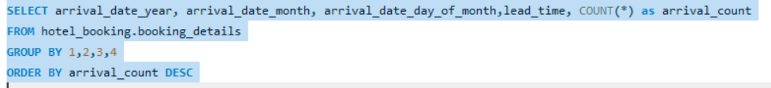

**Summary statistics for lead times:**

To calculate summary statistics for lead times, you can use aggregate functions like min(), max(), avg(), count().

This visualization will help us understand the distribution of arrival month and year and visualize

how lead times vary over time

1. To identify peak booking months and analyze reasons for spikes in bookings, including holidays or events, you can perform a few SQL queries.

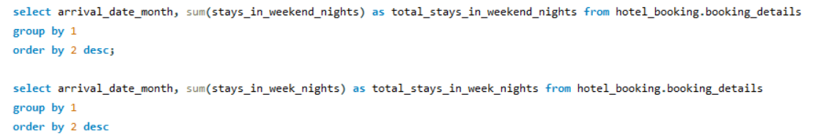

These queries should help you identify peak booking months and analyze the reasons for spikes, including holidays or events.

This visualization will help us identify peak booking months for both week nights and weekend nights.

1. To calculate summary statistics for ADR (Average Daily Rate) and explore differences between Resort Hotel and City Hotel bookings, we use these queries in mysql.

This query calculates summary statistics for ADR, such as the total number of bookings, average ADR, minimum ADR, and maximum ADR for each hotel type.

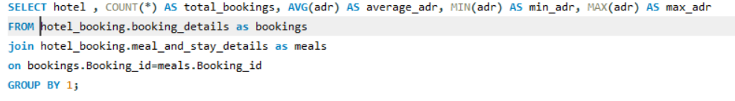

This query focuses on exploring the differences between Resort Hotel and City Hotel bookings by calculating the average ADR and total bookings for each hotel type.

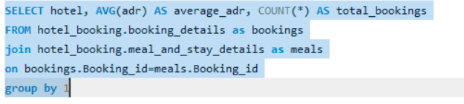

Below is the visual representation of the total bookings, average ADR, minimum ADR and maximum ADR for both Resort Hotel and City Hotel.

1. To analyze the distribution of required car parking spaces for each hotel type and determine if one type attracts more guests with cars, we can use SQL queries to calculate summary statistics and compare the distributions.

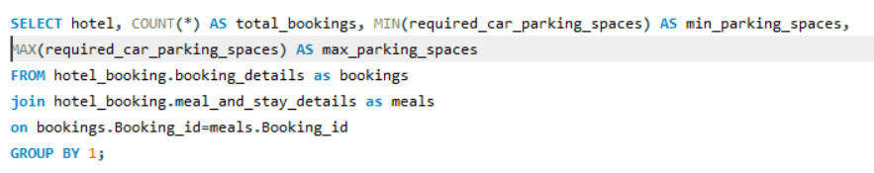

This query calculates summary statistics for the required car parking spaces, including the total number of bookings, average parking spaces, minimum parking spaces, and maximum parking spaces for each hotel type.

Below is the visual representation of the total bookings, minimum parking spaces and maximum parking spaces for both Resort Hotel and City Hotel.

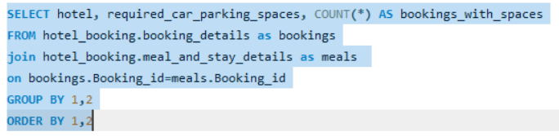

This query provides a breakdown of the number of bookings for each combination of hotel type

and the required car parking spaces. It allows us to compare the distributions of parking

spaces between Resort Hotel and City Hotel.

This chart shows the distribution of car parking spaces for each hotel type.

1. To compare the total number of special requests made by different customer types and identify which customer type makes more requests, we can use SQL queries in mysql.

This query identifies the customer type with the highest total number of special requests. The ORDER BY total special requests DESC sorts the results in descending order, representing the customer type with the most requests.

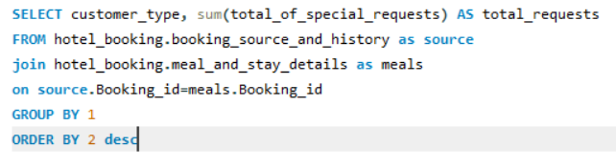

It visualizes the contribution of each customer type to the total number of special requests.

1. To understand the distribution of meal plans (e.g., BB, HB, FB, SC) and identify any patterns or preferences, we can use SQL queries to calculate summary statistics and examine the distribution of meal plans.

In this query, I've included the calculation of the average daily rate (adr) for each meal plan. This allows us to identify patterns or preferences by not only looking at the distribution but also considering the average daily rate associated with each meal plan.

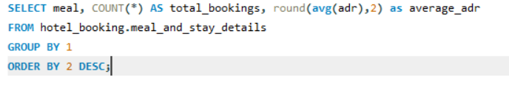

Below visualization compare the total number of bookings for each meal plan type.

1. To investigate the distribution of required car parking spaces and special requests by hotel type and meal plan, and to compare the distribution of meal plans among different customer types, we can use SQL queries in MySQL.

This query provides the distribution of required car parking spaces and special requests based on hotel type and meal plan. It calculates the total number of bookings, average car parking spaces, and average special requests for each combination of hotel type and meal plan.

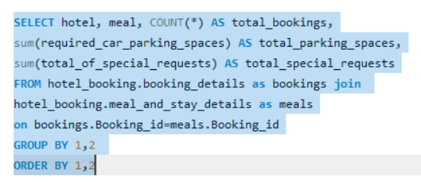

This Chart is useful for comparing the average car parking spaces and total special requests for each combination of hotel type and meal plan.

1. **Compare Meal Plans Among Different Customer Types:**

This query compares the distribution of meal plans among different customer types. It calculates the total number of bookings for each combination of customer type and meal plan, helping us identify preferences among different customer segments.

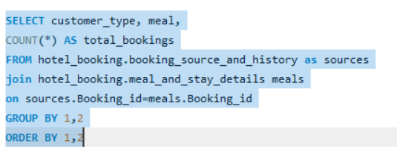

This chart is useful for comparing the distribution of meal plans among different customer types.

1. **Distribution of Bookings Across Market Segments**:

To understand the distribution of bookings across different market segments and calculate summary statistics for lead times within each segment, we use SQL queries in mysql.

This query provides the distribution of bookings across different market segments. It calculates the total number of bookings for each market segment, ordered by the number of bookings in descending order.

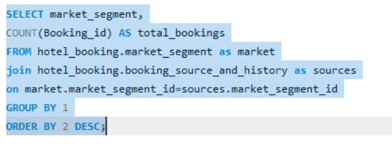

A Bar Chart is suitable for comparing the total number of bookings across different market segments.

**Summary Statistics for Lead Times Within Each Segment:**

This query calculates summary statistics for lead times within each market segment.

It includes the total number of bookings, average lead time, minimum lead time, and maximum lead time for each market segment.

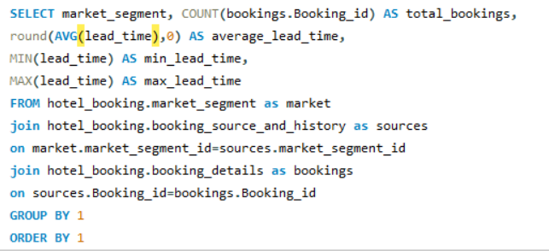

We are comparing here the total number of bookings and lead time statistics across different market segments.

1. To analyze the distribution of bookings through different booking channels and calculate the percentage of bookings through each channel, you can use SQL queries in mysql.

This query calculates the percentage of bookings through each booking channel. It includes the total number of bookings and the percentage of bookings for each channel relative to the total number of bookings.

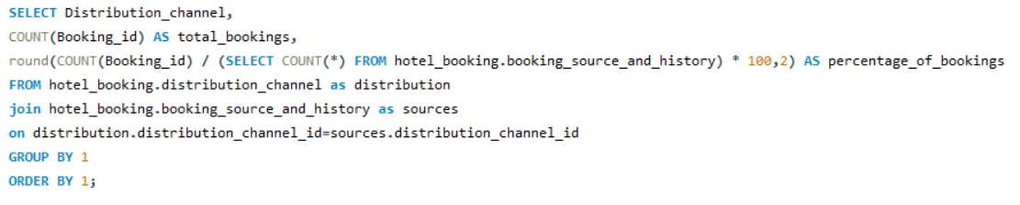

Below is a Pie Chart to show the proportion of bookings through different channels relative to the total

1. To calculate the proportion of repeated guests and investigate their booking behavior, as well as identify any patterns or differences in preferences compared to first-time guests, we use SQL queries in mysql.

This query investigates the booking behavior of repeated guests. To identify patterns or differences compared to first-time guests, you can compare the behavior of repeated guests with that of first-time guests. This query categorizes guests as either "Repeated" or "First-Time" based on the count of their bookings and provides the total repeated guest and proportion of repeated guest.

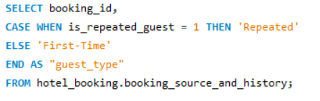



1. To explore the impact of a guest's booking history on their likelihood of canceling a current booking and calculate cancellation rates based on previous cancellations and non-canceled bookings, you can use SQL queries in mysql.

In this query:

Previous cancellations represents the number of previous cancellations by the guest.

Total bookings is the total number of bookings for each group of previous cancellations.

Total canceled bookings is the total number of canceled bookings for each group of previous cancellations.

Cancellation rate is the average cancellation rate for each group of previous cancellations.

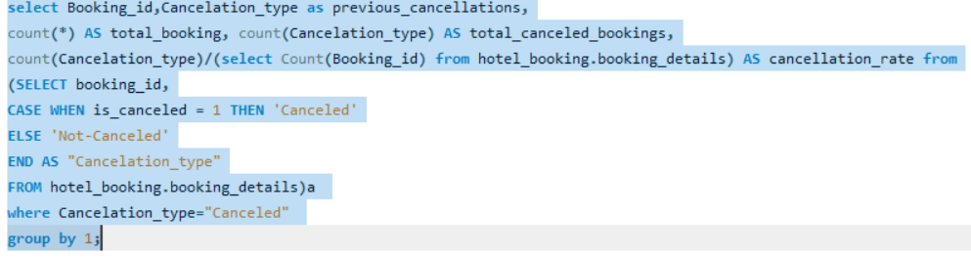

This query provides insights into the cancellation rates based on a guest's booking history.

1. To understand the distribution of reserved and assigned room types and calculate summary statistics for the consistency between them, we can use SQL queries in mysql.

**Distribution of Reserved and Assigned Room Types:**

This query provides the distribution of reserved and assigned room types, showing the total number of bookings for each combination. It can help identify common combinations and potential discrepancies.

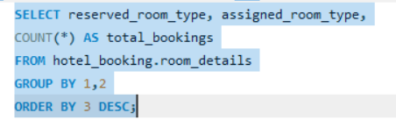

**Summary Statistics for Consistency:**

This query calculates summary statistics for the consistency between reserved and assigned room types. It includes the total number of bookings for each combination and the consistency rate (the proportion of bookings where the reserved and assigned room types match).

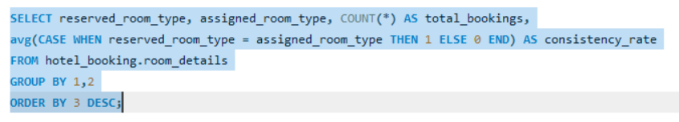

These queries provide insights into the distribution of room types and the consistency between reserved and assigned room types. The consistency rate helps assess how often the reserved room type matches the assigned room type.

1. To analyze the impact of booking changes on cancellation rates and calculate cancellation rates for bookings with different numbers of changes, we are using SQL queries.

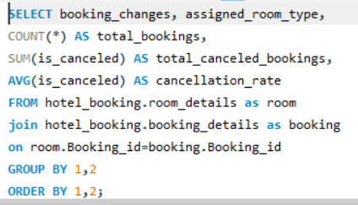

In this query:

booking_changes represents the number of changes made to the booking.

total_bookings is the total number of bookings for each group of changes.

total_canceled_bookings is the total number of canceled bookings for each group of changes.

cancellation_rate is the average cancellation rate for each group of changes.

The results will provide insights into how the number of changes impacts cancellation rates, and we can identify patterns or trends associated with different scenarios.

1. To explore how room type preferences vary across different customer types and identify if certain customer types have specific room preferences, you can use SQL queries in mysql.

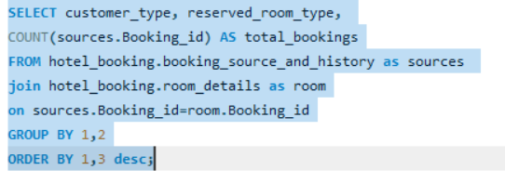

This query provides the room preferences for each customer type, showing the total number of bookings for each combination. We can identify which room types are reserved for specific customer types.

Power Bi Report

Data Modelling

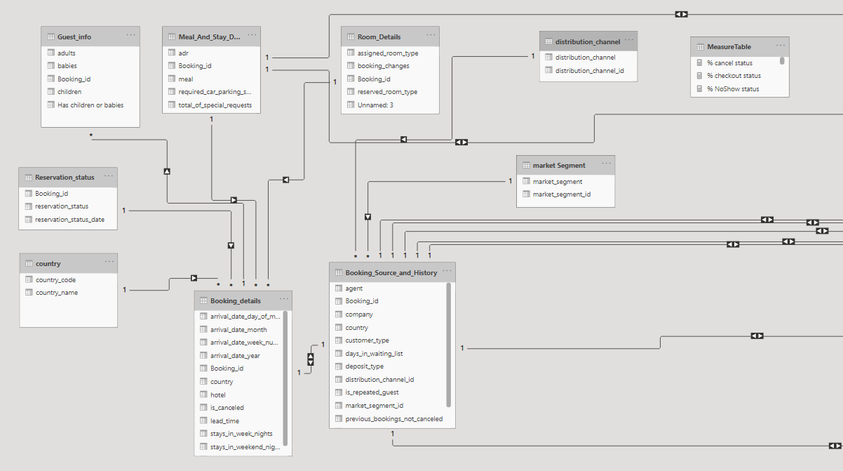

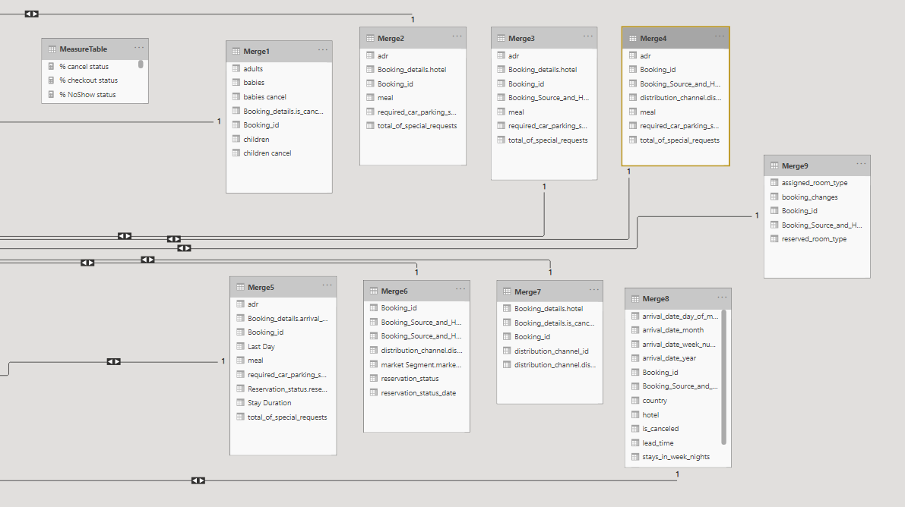

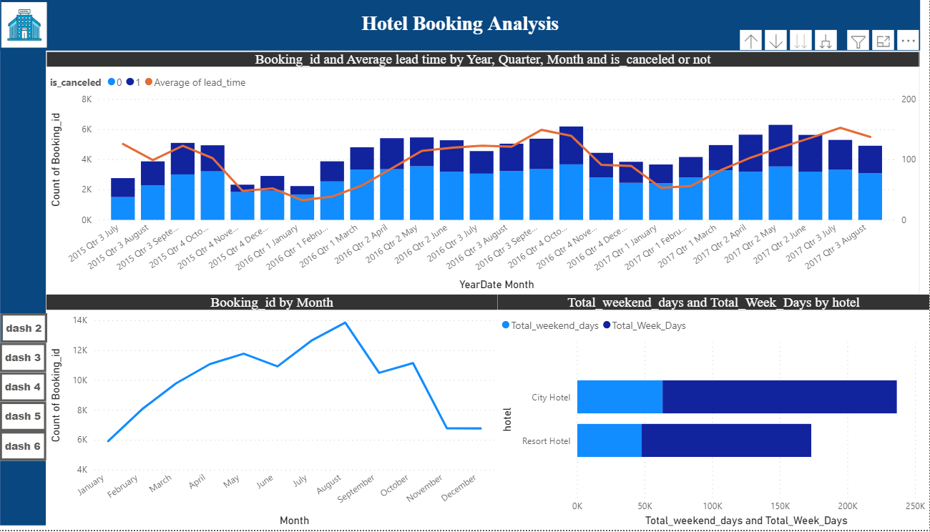

1. Visualize booking trends over the years, including the number of bookings, cancellations, and average lead time. Identify seasonality patterns.

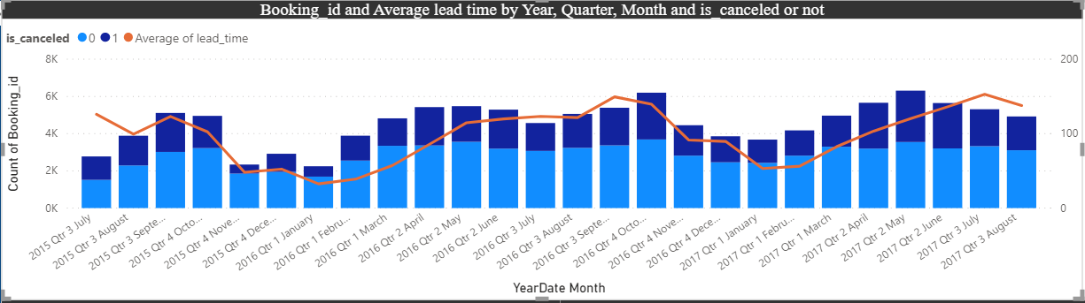

To form the chart I used a line and stacked column chart and in the x axis I used year, in column series has canceled or not canceled, column values count of booking id and line values average of lead time from the booking details table.

Visualizing the number of bookings over the years helps in understanding the overall demand for a service or product. It allows businesses to identify peak booking periods, low seasons, and any long-term trends. Analyzing this data can assist in resource planning, marketing strategies, and revenue forecasting.

Monitoring the number of cancellations provides insights into customer behavior and satisfaction. A sudden increase in cancellations might indicate issues with customer experience, marketing messaging, or external factors.

Average lead time represents the average duration between making a booking and the actual arrival or usage date. Visualizing this metric helps in understanding how far in advance customer.

Seasonality refers to recurring patterns or fluctuations in data that happen at specific times during the year. Identifying seasonality patterns is crucial for businesses to anticipate and prepare for variations in demand.

In summary, visualizing booking trends and identifying seasonality patterns is about extracting meaningful insights from historical data to make informed decisions. Businesses can use this information to enhance customer satisfaction, improve operational efficiency.

1. Analyze monthly booking patterns to identify peak months and optimize marketing strategies.

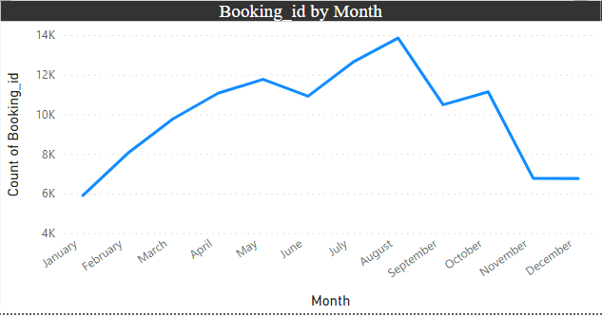

To form the chart I used a line chart and in the x axis I used year and in values count of booking id from the booking details table

Identifying peak months allows businesses to focus their marketing efforts when demand is naturally higher, maximizing revenue potential.

Knowing when demand is expected to peak helps in better resource planning, including staffing, inventory, and operational capacity.

Tailoring marketing strategies to align with peak months enables businesses to engage with customers when they are more likely to make bookings.

Optimizing marketing strategies based on historical booking patterns can provide a competitive advantage by ensuring that promotional efforts are well-timed and effective.

In summary, analyzing monthly booking patterns and optimizing marketing strategies based on peak months is a data-driven approach to enhance business performance, increase customer acquisition, and improve overall marketing effectiveness.

1. Compare stays in weekend nights and weekday nights to determine preferences and variations by hotel type.

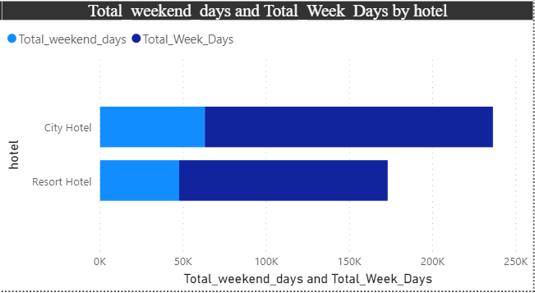

To form the chart I used a stacked bar chart and in the x axis I used hotel and in values total weekend days and total week days.

Knowing guest preferences allows hotels to tailor marketing campaigns to specific audiences, promoting relevant offers and experiences.

Understanding variations in stays helps hotels optimize staffing, services, and amenities to align with guest expectations on different days of the week.

Aligning services with guest preferences enhances the overall guest experience, leading to higher satisfaction and potential repeat business.

Hoteliers can make informed strategic decisions, such as pricing strategies, promotional activities, and partnerships based on when guests are most likely to book.

In conclusion, comparing stays on weekend nights and weekday nights to determine preferences and variations by hotel type is a strategic analysis that enables hotels to tailor their offerings and services to meet the specific needs of their target audience. It provides valuable insights for marketing, operations, and overall business strategy.

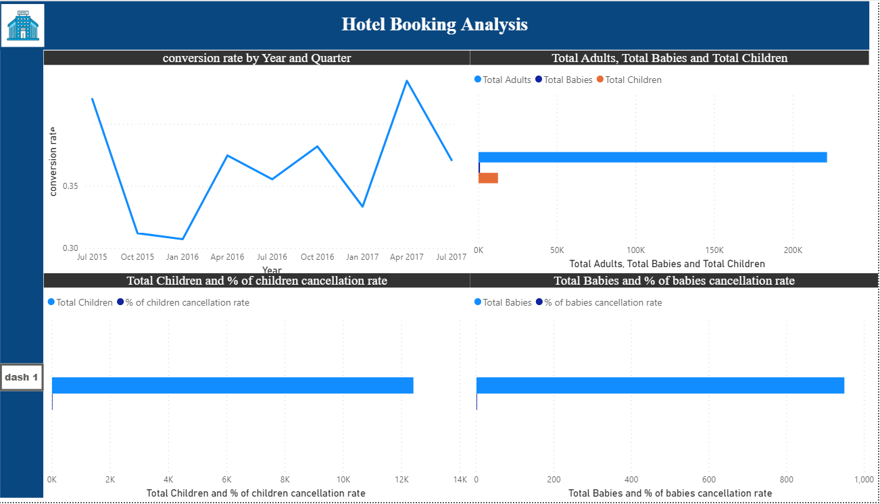

1. Calculate and visualize the booking conversion rate (canceled bookings to total bookings) over time.

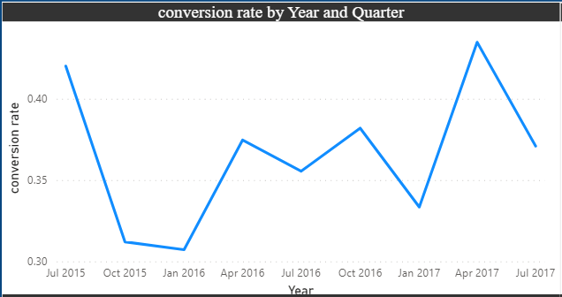

To form the chart I used a line chart and in the x axis I used year and in values conversion rate from booking details table.

I created a measure for conversion rate.

conversion rate = [total cancellations]/[Total Booking]

Understanding booking conversion rates provides insights into customer behavior, helping to anticipate and respond to changing preferences.

In summary, calculating and visualizing the booking conversion rate over time is a valuable analysis for understanding customer behavior, optimizing operations, and making informed strategic decisions in the hospitality industry.

1. Visualize the distribution of adults, children, and babies in bookings. Explore the impact of children and babies on cancellation rates.

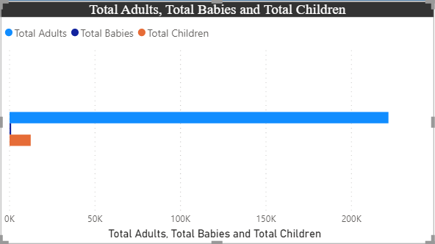

To form the chart I used a clustered bar chart and in values I used total adults, total babies and total children.

I created measures for total adults, total babies and total children.

Total Adults = sum(Guest_info[adults])

Total Babies = sum(Guest_info[babies])

Total Children = SUM(Guest_info[children])

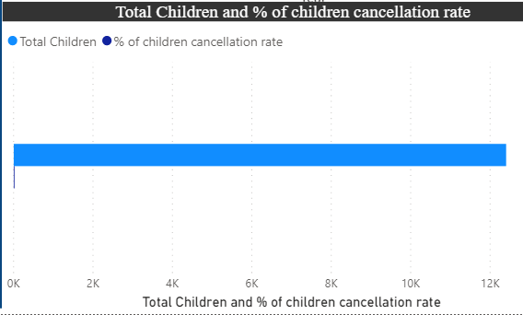

To form the chart I used a clustered bar chart and in values I used total children and % of children cancellation rate.

I created measures for % of children cancellation rate

% of children cancellation rate=sum(Merge1[children cancel])/[Total Children]

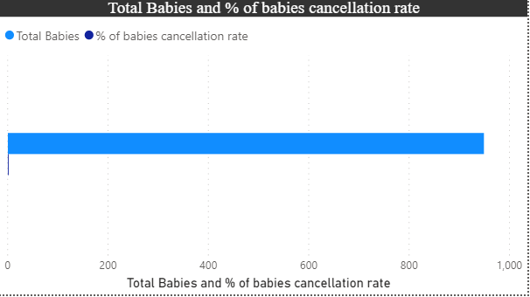

To form the chart I used a clustered bar chart and in values I used total babies and % of babies cancellation rate.

I created measures for % of children cancellation rate

% of babies cancellation rate=sum(Merge1[babies cancel])/[Total babies]

A higher cancellation rate for bookings with children or babies may suggest that guests with families are more likely to change plans or encounter unexpected circumstances.

Alternatively, a lower cancellation rate may indicate that families plan more thoroughly and commit to their bookings.

By visualizing the distribution of adults, children, and babies and exploring their impact on cancellation rates, businesses can gain valuable insights into guest behavior, leading to more informed operational decisions and improved guest satisfaction.

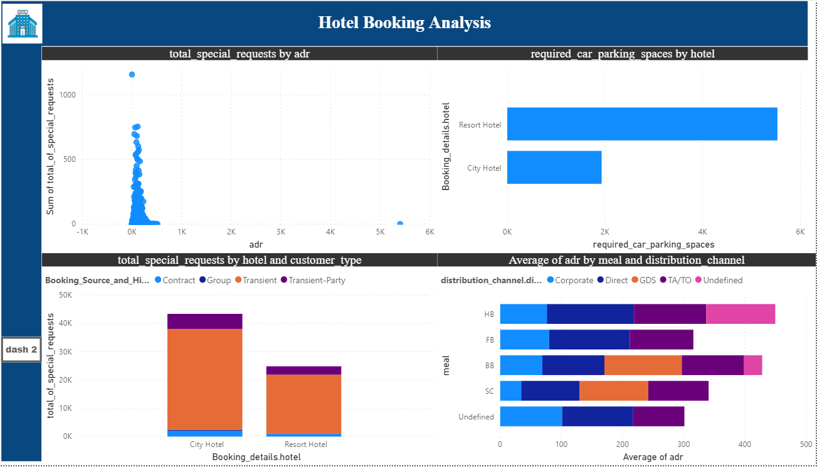

1. Analyze the distribution of Average Daily Rates (ADR) and identify correlations with the number of special requests made by guests.

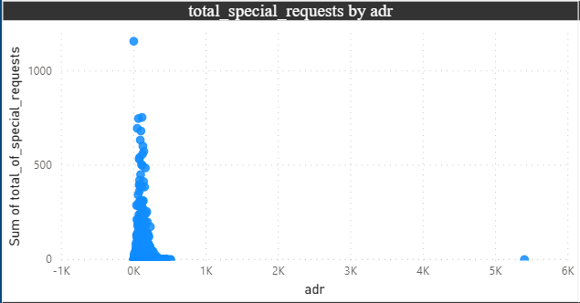

To form the chart I used a scatter chart and in the x axis I used ADR and in values sum of total special request from meal and stay details table.

Understanding the correlation helps in refining pricing strategies. It allows businesses to adjust pricing based on the expected level of additional services requested by guests.

The correlation provides insights into the types of services or amenities that guests may value based on their willingness to pay a higher ADR.

In summary, analyzing the distribution of ADR and its correlation with the number of special requests provides valuable insights for pricing strategies, service customization, and overall guest satisfaction. Businesses can use this information to optimize their offerings and enhance the guest experience.

1. Visualize the relationship between the number of required car parking spaces and booking types (Resort Hotel vs. City Hotel).

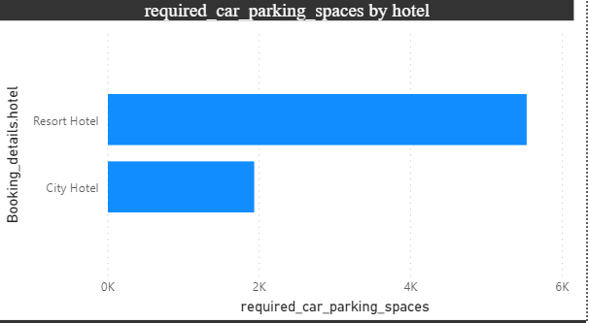

To form this chart I used a clustered bar chart and in the x axis I used hotel and in values sum of required car parking spaces by merging two table(merge2) booking details and meal and stay details table.

Knowledge of parking space requirements can be used in marketing and communication strategies. For example, Resort Hotels might emphasize spacious parking facilities in their promotions.

For City Hotels, understanding parking needs is relevant to urban planning and coordination with local authorities.

In summary, visualizing the relationship between the number of required car parking spaces and booking types provides insights into guest preferences and operational considerations. It allows hotels to tailor their services and infrastructure based on the parking needs associated with different hotel types.

1. Use Power BI to explore how the total number of special requests made by guests varies by hotel type and customer type (e.g., Transient, Group).

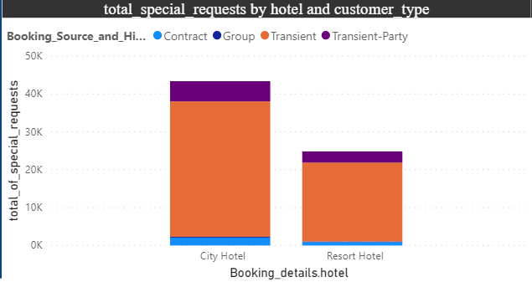

To form this chart I used a stacked column chart and in the x axis I used hotel and in values total of special request by merging three table(merge3) booking details, meal and stay details table and booking source and history table.

Meeting and exceeding guest expectations regarding special requests contributes to overall satisfaction.

Efficiently allocating resources based on the types of special requests helps in operational efficiency.

Understanding and responding to guest preferences can provide a competitive advantage in the hospitality industry.

In conclusion, using Power BI to explore how the total number of special requests varies by hotel type and customer type is a powerful way to gain insights into guest behavior, allowing hotels to optimize services and improve overall guest satisfaction.

1. Explore meal plans and their impact on Average Daily Rates (ADR). Analyze meal plan preferences and their association with booking channels.

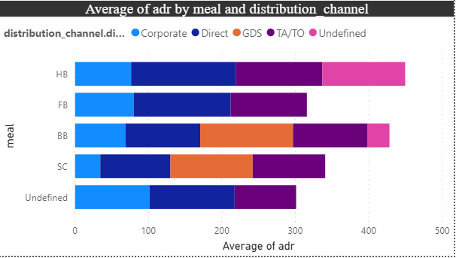

To form this chart I used a stacked bar chart and in the x axis I used hotel and in values total of special request by merging three table(merge4) meal and stay details table, booking source and history table, distribution channel.

Understanding the impact of meal plans on ADR helps in setting competitive prices and maximizing revenue. Offering popular meal plans enhances guest satisfaction, as guests are more likely to choose plans that align with their preferences. Leveraging insights into meal plan preferences and their association with booking channels provides a competitive advantage in the hospitality market.

In conclusion, exploring meal plans, their impact on ADR, and analyzing preferences in association with booking channels using Power BI helps hotels optimize pricing, enhance guest satisfaction, and tailor marketing strategies for increased efficiency and competitiveness.

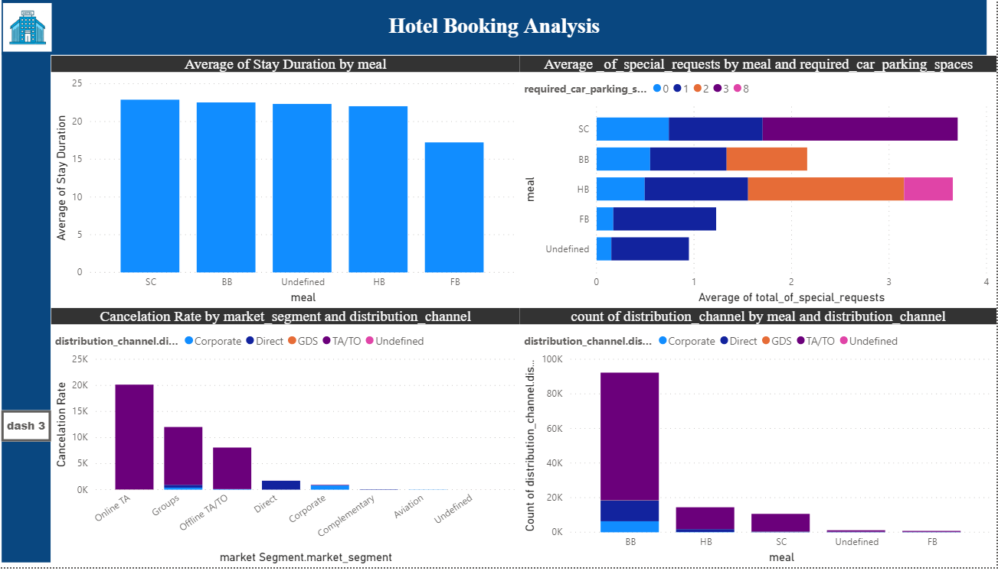

1. Analyze how meal plans correlate with stay duration and investigate any differences in stay lengths based on meal plans.

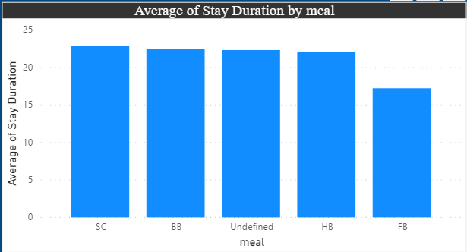

To form this chart I used a stacked column chart and in the x axis I used meal and in values average of stay duration by merging three table(merge5) booking details, meal and stay details table and reservation status table.

I created a last day column to create the stay duration column in the merge table.

LastDay=Day(Merge5[Reservation_status.reservation_status_date])

StayDuration=DAY(Merge5[Booking_details.arrival_date_day_of_month]-Merge5[Last Day])

Understanding how meal plans correlate with stay duration aids in optimizing resources and services for different guest needs.

If certain meal plans are associated with longer stays, this can impact revenue projections and allow for strategic pricing adjustments.

In conclusion, analyzing how meal plans correlate with stay duration and investigating differences in stay lengths based on meal plans using Power BI helps hotels understand guest behavior, optimize operations, and tailor services to enhance guest satisfaction.

1. Correlate parking requirements and special requests with different meal plans. Determine if certain meal plans result in more requests or parking needs.

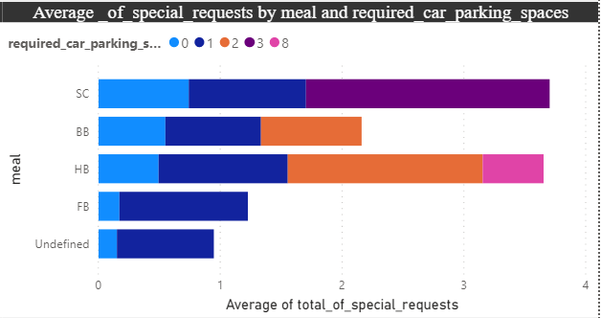

To form this chart I used a stacked column chart and in the x axis I used meal and in values average of total of special request and in legend required car parking spaces from the meal and stay details table.

Efficiently managing parking spaces and resources based on meal plan preferences improves overall operational efficiency.

The insights gained can inform marketing strategies, helping hotels target specific guest segments with tailored offerings.

Understanding the correlation allows hotels to customize services for guests based on their meal plan choices, leading to higher guest satisfaction.

In conclusion, correlating parking requirements and special requests with different meal plans using Power BI helps hotels gain insights into guest behavior, optimize operations, and enhance overall guest satisfaction by aligning services with meal plan preferences.

1. Explore how meal plans are distributed across various booking channels. Analyze if certain channels are associated with specific meal plans.

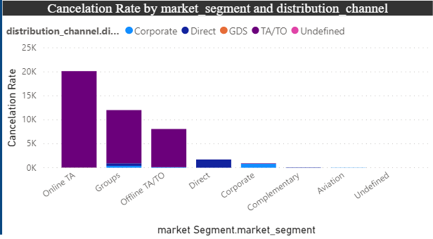

To form this chart I used a stacked column chart and in the x axis I used market segment and in values cancelation rate and in legend distribution channel by merging three tables(merge 6) booking source and history, distribution channel, market segment table.

I created a measure for cancelation rate.

CancelationRate=COUNTAX(FILTER(Merge6,Merge6[reservation_status]="Canceled"),1)

Efficiently targeting marketing efforts by aligning promotions with meal plans preferred by guests from different channels improves marketing efficiency.

The insights gained can inform strategic decisions related to pricing, promotions, and overall hotel management.

Leveraging knowledge about meal plan preferences associated with booking channels provides a competitive edge in the hospitality industry.

In conclusion, exploring how meal plans are distributed across various booking channels and analyzing associations between channels and specific meal plans using Power BI helps hotels tailor their services and marketing strategies to meet guest preferences and improve overall operational efficiency.

1. Visualize booking distribution across different market segments and analyze cancellation rates within each segment.

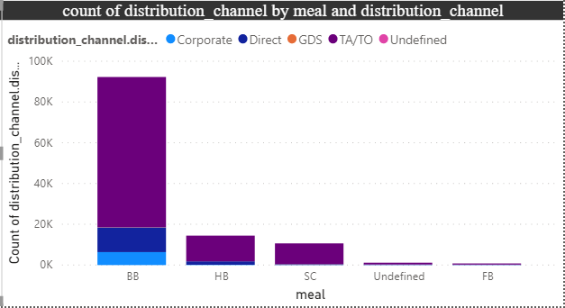

To form this chart I used a stacked column chart and in the x axis I used meal and in values count of distribution channel and in legend distribution channel by using (merge 4 table) meal and stay details table, booking source and history table, distribution channel.

Knowing the distribution of bookings across market segments helps in targeted guest outreach and ensures that marketing efforts align with the preferences of specific segments.

Identifying segments with higher cancellation rates allows hotels to implement strategies to mitigate cancellations, such as flexible cancellation policies or targeted retention efforts.

The insights gained can inform strategic decisions related to pricing, promotions, and overall hotel management.

In conclusion, visualizing booking distribution across different market segments and analyzing cancellation rates within each segment using Power BI helps hotels tailor their services, marketing strategies, and operational planning to meet the preferences and behaviors of guests in different segments, ultimately improving overall efficiency and guest satisfaction.

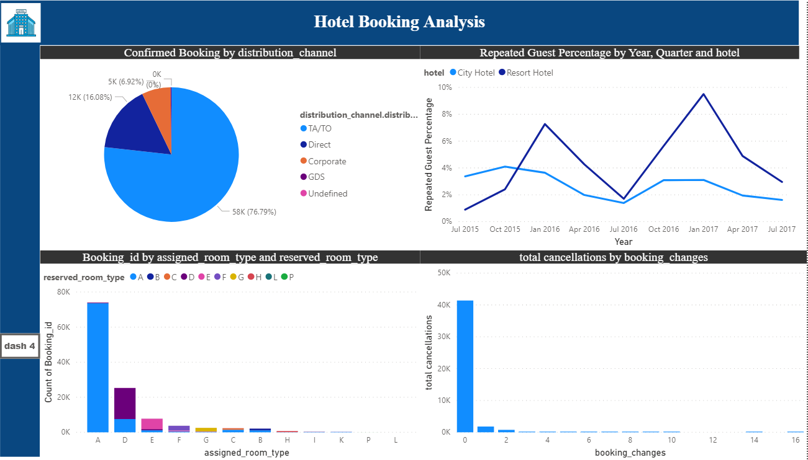

1. Compare the effectiveness of booking distribution channels in generating confirmed bookings. Identify the most commonly used channels by guests.

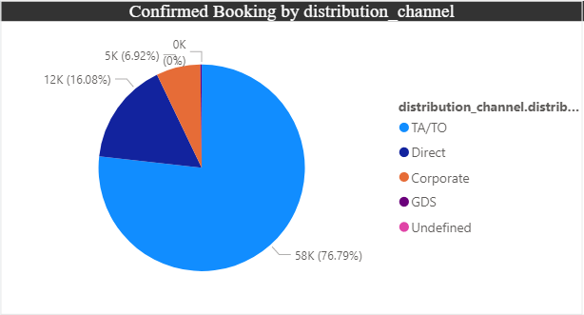

To form this chart I used a pie chart and in legend used distribution channel and values confirmed booking by using (merge 7 table) booking details and distribution channel.

I created one measure for confirmed booking.

ConfirmedBooking=COUNTAX(FILTER(Merge7,Merge7[Booking_details.is_canceled]=0),Merge7[Booking_details.is_canceled])

Knowing which booking channels are most effective allows hotels to allocate resources efficiently, whether it be marketing budgets or staff efforts.

Efficiently targeting marketing efforts by focusing on high-performing channels improves the overall efficiency of promotional campaigns.

Leveraging knowledge about effective booking channels provides a competitive advantage in the market.

In conclusion, comparing the effectiveness of booking distribution channels in generating confirmed bookings using Power BI helps hotels optimize marketing strategies, enhance guest experience, and allocate resources efficiently, ultimately contributing to revenue growth and competitive advantage.

1. Visualize the percentage of repeated guests for each hotel type (Resort Hotel vs. City Hotel) over time. Explore factors influencing guest retention.

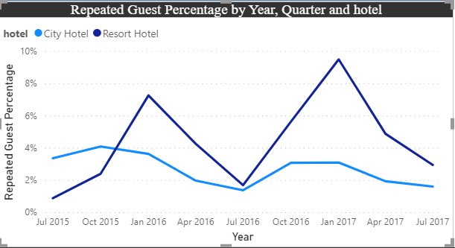

To form this chart I used a line chart and in x axis I used year, values repeated guest percentage by using (merge 8 table) booking details and booking source and history.

I created a measure for RepeatedGuestPercentage.

RepeatedGuestPercentage=DIVIDE(CALCULATE(COUNTROWS(Merge8),Merge8[Booking_Source_and_History.is_repeated_guest]=1),CALCULATE(COUNTROWS(Merge8)),0)

Monitoring guest retention over time helps in effective guest relationship management, allowing hotels to nurture and maintain relationships with repeat guests.

Understanding factors influencing retention allows hotels to improve guest experience and tailor services to meet the expectations of repeat guests.

Leveraging knowledge about guest retention provides a competitive advantage, helping hotels stand out in the market.

In conclusion, visualizing the percentage of repeated guests for each hotel type over time using Power BI allows hotels to gain insights into guest loyalty, identify successful retention strategies, and adapt their approach to improve overall guest satisfaction and loyalty.

1. Visualize the distribution of reserved and assigned room types. Analyze whether guests tend to receive the room type they initially reserved.

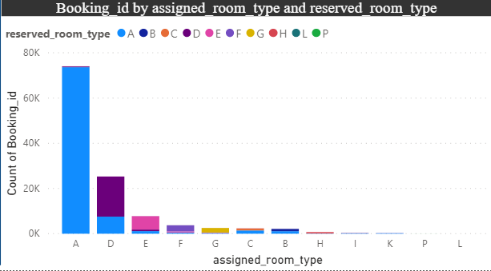

To form this chart I used a stacked column chart and in x axis I used assigned room type, values count of booking id and in legend reserved room type by using room details table.

Ensuring that guests receive the room type they reserved contributes to an enhanced guest experience, aligning the hotel's offerings with guest expectations.

Consistent alignment between reserved and assigned room types is a key indicator of the hotel's commitment to providing quality services.

Monitoring room assignment alignment allows hotels to continuously improve their processes and systems to meet guest expectations.

In conclusion, visualizing the distribution of reserved and assigned room types using Power BI and analyzing the alignment between these types helps hotels understand how well they meet guest expectations. This analysis contributes to enhancing guest satisfaction, improving operational efficiency, and ensuring the overall quality of the guest experience.

1. Investigate the relationship between the number of booking changes made by guests and their likelihood of canceling a booking.

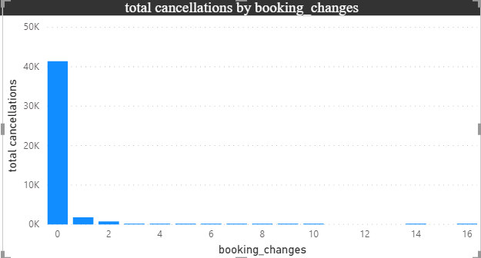

To form this chart I used a stacked column chart and in x axis I used booking changes, values total cancelation by using room details table.

For total cancellation I created a measure.

totalcancellations=SUMX(FILTER(Booking_details,Booking_details[is_canceled]=1),Booking_details[is_canceled])

Understanding the relationship between booking changes and cancellations helps hotels make informed decisions about policies, procedures, and customer communication.

Insights into guest behavior around booking changes contribute to optimizing services and providing a better overall guest experience.

In conclusion, investigating the relationship between the number of booking changes made by guests and their likelihood of canceling a booking using Power BI allows hotels to understand guest behavior patterns. This analysis assists in making operational decisions, optimizing services, and tailoring communication strategies to enhance the overall guest experience and mitigate risks associated with cancellations.

**Conclusions**

* Around 60% bookings are for City hotel and 40% bookings are for Resort hotel, therefore City Hotel is busier than Resort hotel. Also the overall adr of City hotel is slightly higher than Resort hotel.
* Mostly guests stay for less than 5 days in hotel and for longer stays Resort hotel is preferred.
* Both hotels have significantly higher booking cancellation rates and very few guests less than 3 % return for another booking in City hotel. 5% guests return for stay in Resort hotel.
* Most of the guests came from european countries, with most no. of guest coming from Portugal.
* Guests use different channels for making bookings out of which most preferred way is TA/TO.
* For hotels higher adr deals come via GDS channel, so hotels should increase their popularity on this channel.
* Almost 40% of bookings via TA/TO are cancelled.
* Not getting same room as reserved, longer lead time and waiting time do not affect cancellation of bookings. Although different room allotment do lowers the adr.
* July- August are the most busier and profitable months for both of hotels.
* Within a month, adr gradually increases as month ends, with small sudden rise on weekends.
* More number of people in guests results in more number of special requests.
* Bookings made via complementary market segment and adults have on average high no. of special request.
* For customers, generally the longer stays (more than 15 days) can result in better deals in terms of low adr.

**Thank you**